

Machine Learning Foundations
Professor Prashanth L A
Department of Computer Science and Engineering
Indian Institute of Technology, Madras
Projections
Welcome to lecture 3 in week 3 of Machine Learning Foundations. As you know, we are going to continue the discussion on topics in linear algebra. In particular, in this lecture, we will be looking at the concept of projections, which are very, very important because they have a strong connection to least squares problems.
And in this particular lecture, I will be motivating the need for projections. And I will take a simple example where we will understand how to project onto a line. Now, the idea that underlies projection onto a line can be easily extended to projection onto a subspace. For example, the column space of a matrix which we will be looking at in the next lecture.
But in this particular lecture, we will be looking at the need for projections, which will be motivated using solutions to linear system of equations in the case where they are inconsistent, and then we will understand how to project onto a line.
(Refer Slide Time: 1:15)
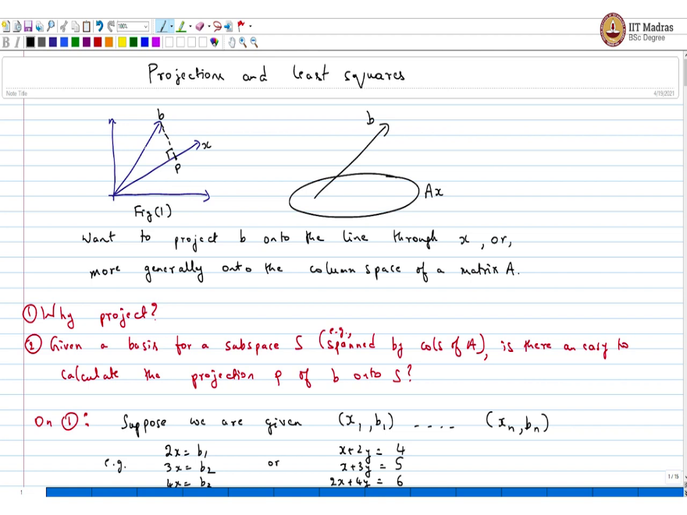
So, welcome to yet another lecture on Machine Learning Foundations. We will continue the discussion on least squares and but before that, we will be talking about projections. So, today's talk is focused on projections, which has strong connections to least squares. So, what I mean in terms of geometry, what you want to do is you have a vector, you have some other line, in this b, you want to project b onto x and this is the right angle this point is p. In general, the more generalization is b is here and you have some linear space Ax.
So, want to project b onto the line through x or more generally onto column space of a matrix A. The important question is why do you, why project, what is the requirement or the need for projection? And this is the first question that we are going to answer, the second question is given a basis for a subspace say S More concretely say spanned by columns of A. For example. Now, is there an easy way to calculate the projection p of b onto S? So, these are two questions that we are going to answer today.
(Refer Slide Time: 3:52)
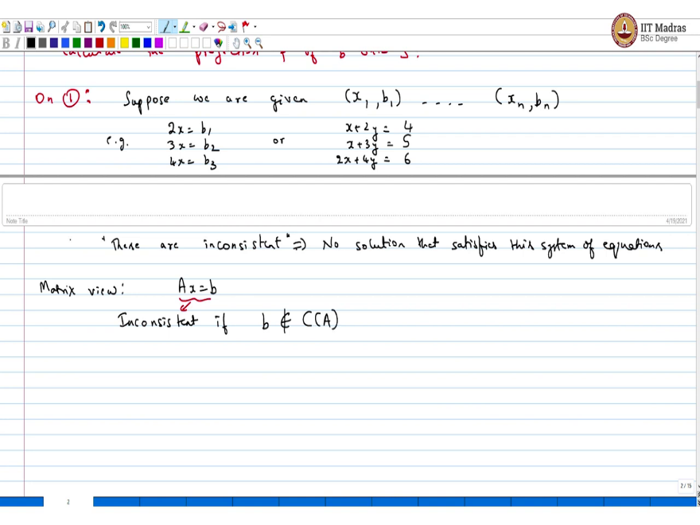
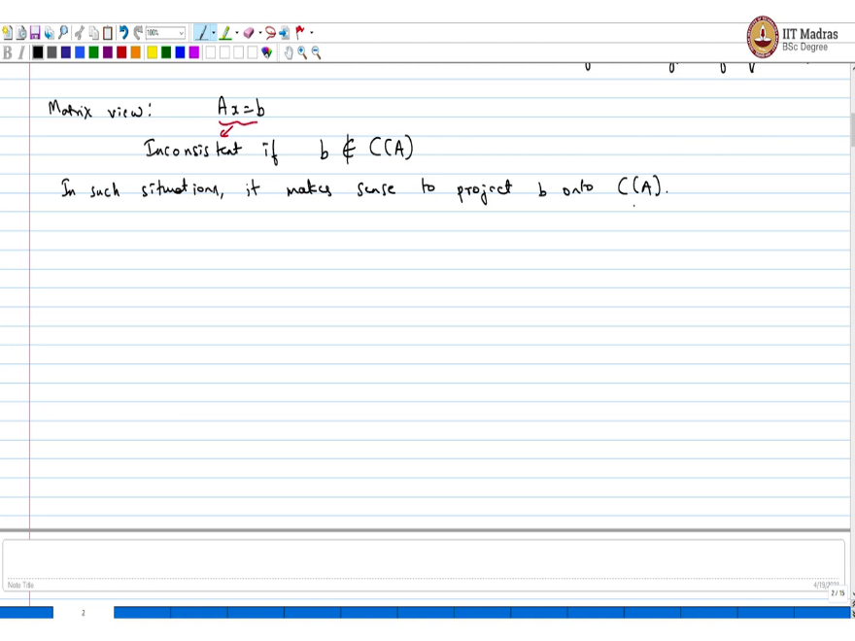
Let us look at question 1. On 1, suppose we are given data, say x1, b1 until xn, bn, for example, you could have a setup like 2x = b1, 3x = b2 and 4x = b3 or something else x + 2y = 4, x + 3y = 5 and 2x + 4y = 6. Now, if you look at the system just look at these systems these systems are, these are inconsistent, has no solution that satisfies this system of equations.
Now, if you want to look at the matrix view, the matrix view is, you can make up a system of equations. And inconsistent says inconsistent if b does not belong to the column space of A and in such situations it makes good sense to project b onto column space of A. So, that is the thing.
So, this is the motivation in many situations you are not able to solve Ax = b, because, if you look at the columns of A, b is not there, b is not a linear combination of the columns of A, it can be outside the column space. And if there is no way to solve this equation, what is the next best thing you can do, the best thing you can do is you project.
(Refer Slide Time: 6:28) , 6:59
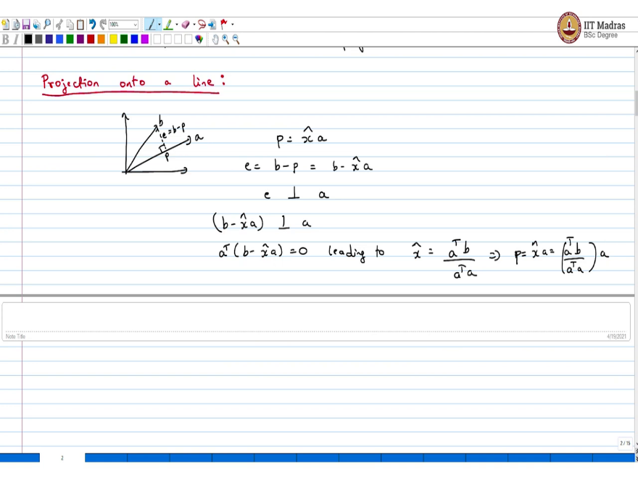
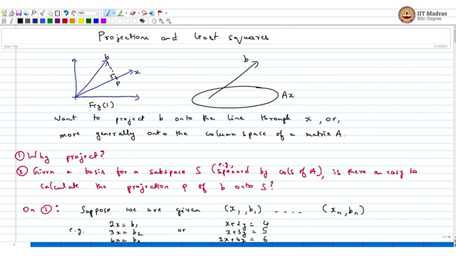
So, let us start the discussion with projection onto something very simple. The very first figure that had done projection onto a line. So, if you look up again, so I can copy this. So, look at this figure, the very first figure, let me call this figure 1. If you look at figure 1, remember this thing or it may be worth drawing this again. You have b, you have x, and you have this 90 degree and call this p and call the rest as e, e = b - p.
Now, the projection p is sums we want to project this not onto x sorry, we want to project this onto a, let me call this a. p = some scalar multiple of the of a. Now the question is, which is the best, we know e = b - p = b - x hat a and we know that e is perpendicular to a which is like saying that b - exactly perpendicular to a.
Or the dot product in this case, it is just a straightforward product is 0. Leading to what, what is the solution for x hat, juts do this on your own, pause the video transpose b divided by a transpose a. Now it is the projection implies, let me write it implies p = x hat a which is nothing but a transpose b by a transpose a into a. So, that is projection onto the line, we will move on to projection onto a space on but let us understand this projection business a little more carefully.
(Refer Slide Time: 9:07)
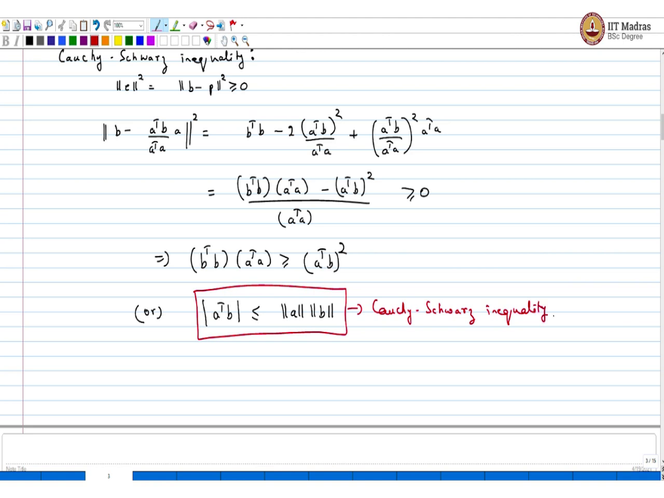
In fact, as a slight detour, we can look at what is called Cauchy Schwarz. Cauchy Schwarz inequality. This is a very well-known inequality with several proofs. We can show. I will show you a short proof using projections. We know that this is the length of the vector e, which is here if you look at this figure, and that is a positive length quantity. And so I can write this as b - p. This I know is greater than equal to 0.
Now, let us substitute whatever we have learned just recall p is this, so I can write b as p -, sorry b - a transpose b divided by a transpose a into a the square, and this is nothing but just a - b square. Let us square up the first - 2 × a transpose b square divided by a transpose a + a transpose b, then a transpose a square into the transpose a.
Now, this can be reordered as b transpose b into a transpose a - a transpose b square divided by a transpose a. And we know that this is non negative, we just implies b transpose b the numerator is non negative, just implies b transpose b into a transpose a is greater than equal to a transpose b square or a transpose b absolute value is less than equal to the length of a into the length of b and this is Cauchy Schwarz. This is Cauchy Schwarz inequality and reasonably short proof for that.
(Refer Slide Time: 11:45)
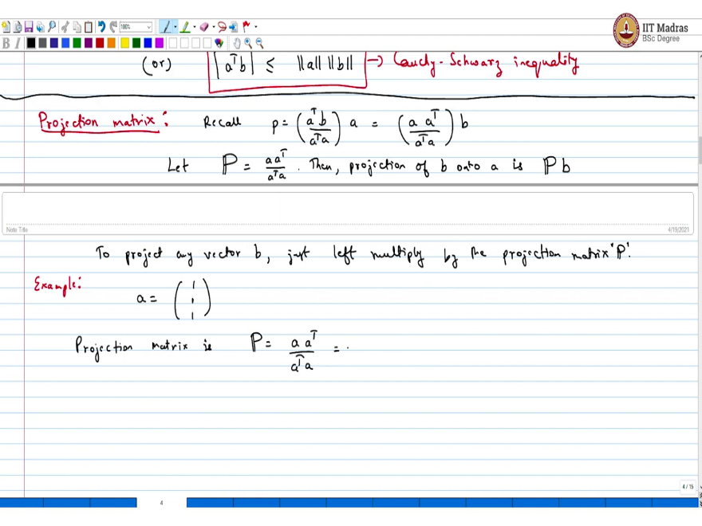
So, moving on, we look at what is called a projection matrix. Recall p was a into sorry, we wrote it this way a transpose b by a transpose a into a which I can write as a into a transpose divided by a transpose a into b. Let this capital P be defined as this matrix a into a transpose divided by a transpose a. Then projection of b onto a is just p × not b. So, if I want to project any vector, then I just have to left multiply by, to project any vector b, just left multiply by the projection matrix, simple enough thing.
So, let us look at a quick example, a simple one. Imagine you are looking at this vector 111, what is the projection matrix? The projection matrix is, this a into a transpose divided by a transpose a, just pause the video for your own benefit, work this out by hand on your own. I am going to give out the answer.
(Refer Slide Time: 14:21)
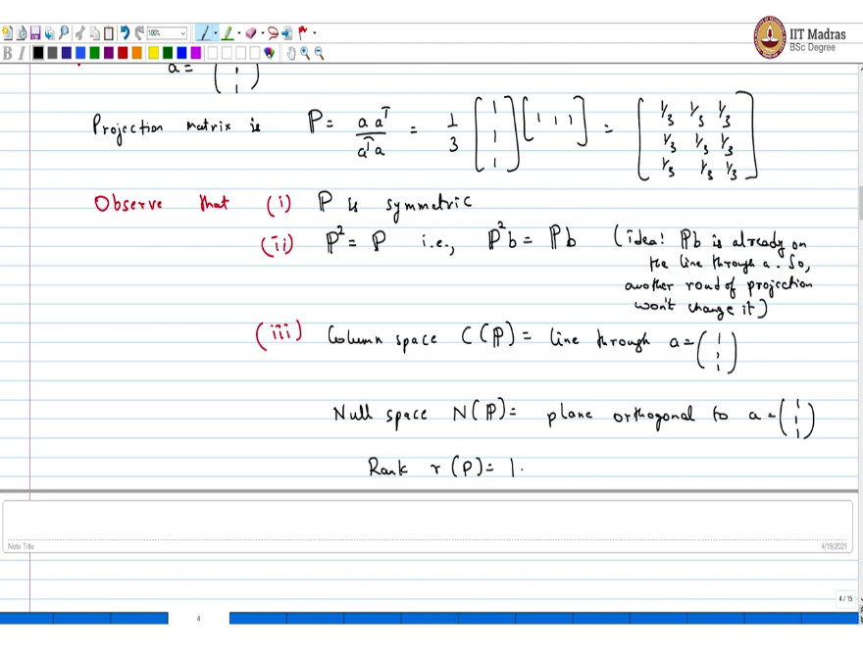
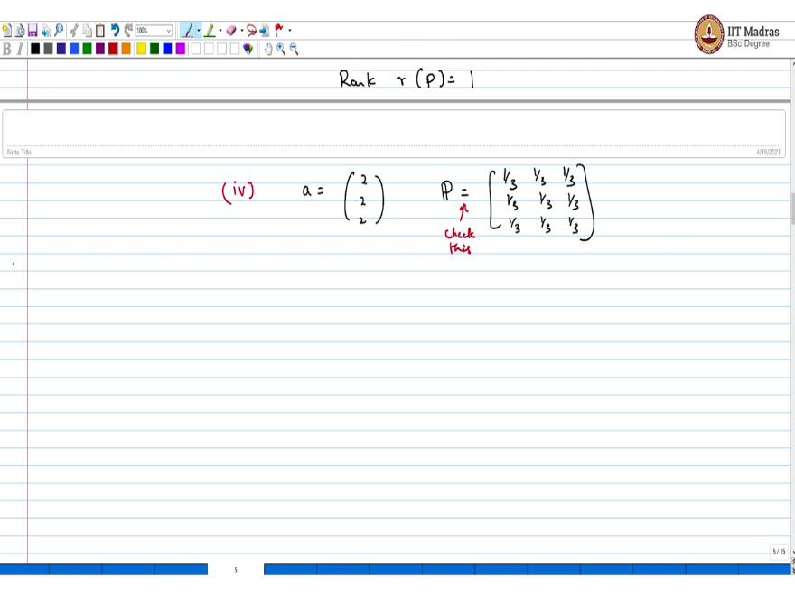
It is going to be 1 by 3 into 1 1 1; 1 1 1, which is just the matrix with all 1 by 3 matrix. So, that is your projection matrix. Now, in this particular case, observe that 1; the matrix P is symmetric and this is something you can also see the second thing that you can see is p squared = p. And this makes intuitive sense, what is, what does left multiplication by p achieve, it brings it onto the line through a.
And the next time if you project again, which is like pb is already on the line, if you project again, you are going to get back the same quantity. So, p square has to be p simply because you have already projected by doing p, that is p square b = pb. The idea is pb is already on the line through a, so another round of projection will not change it. So, once you project you are already, wherever you want to be. Say, on the line a, and if you project again, it is not going to change anything.
Third thing, what is the column space C of p? If you look at this matrix here, the matrix given in the example above, then the column space of matrix is just the line through a. So, what is the null space p? This is nothing but the plane orthogonal to a. And what is the rank? Rank r p = 1.
The last thing that I want you folks to observe is this. If instead of projecting onto a = 1 1 1, if I set a as 2 2 2, then what would be the projection matrix? You can go back and verify, it turns out to be the same as before. So, what this say, check this, so either pause or do it later + do it once, the projection matrix would not change the same line and projection would not change. So right now, the next thing we are going to do is, we are going to explore the connection of this to least squares.
Quick summary before we end this lecture, in this lecture, we understood what it means to project onto a line. And even before that, we also understood why we need predictions. The motivation was that, there are several linear systems where, like Ax = b, where b is not in the column space of A, which just means that you cannot solve the system, which was the inconsistent case.
But what is the best approximation you can arrive at, and a popular alternative is least squares and to solve such least squares problems, its equivalent geometric idea is to do projections, orthogonal projections onto the column space of a. So, that is very important. So, projections are closely tied to least squares problems. And we also as a side benefit, in this course, we also saw a simple proof of Cauchy Schwarz inequality, once you have understood what it means to project.
In the subsequent lecture, we will generalize this idea of projection onto a line to the case where you want to project onto a subspace in particular we will be projecting onto the column space of a matrix and we will use this idea to solve least squares problems and that you will see in the subsequent lectures.

